K.KRISHIKKA

192111710

ITA 1478- Ethical Hacking for Mobile Applications

1.INFORMATION GATHERING USING THE HARVESTER

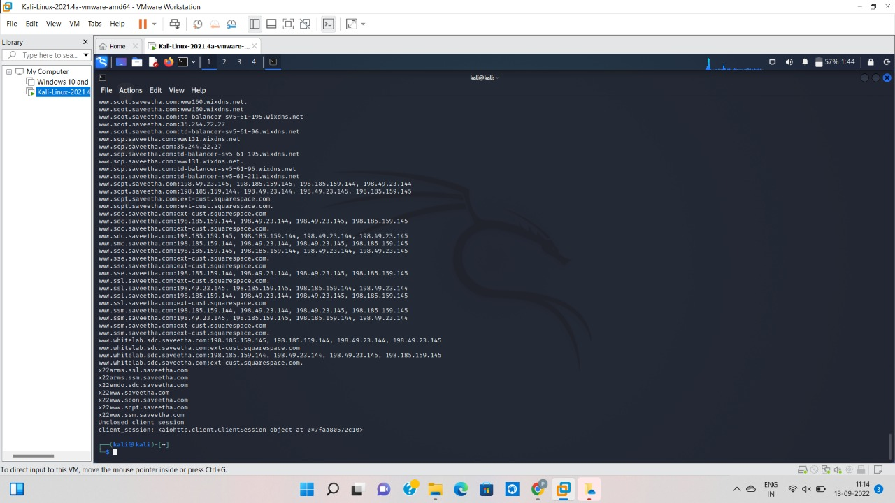

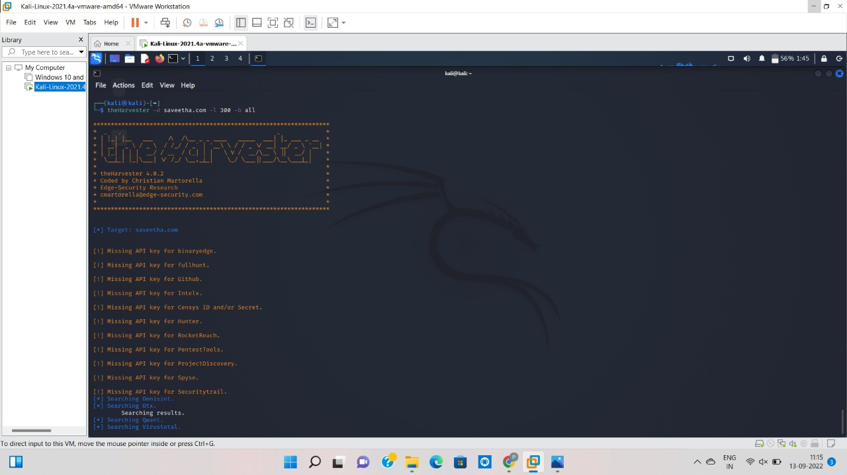

2.OPEN SOURCE INTELLIGENCE GATHERING USING OSRFramework

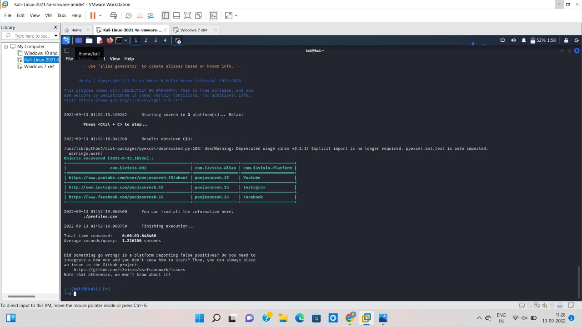

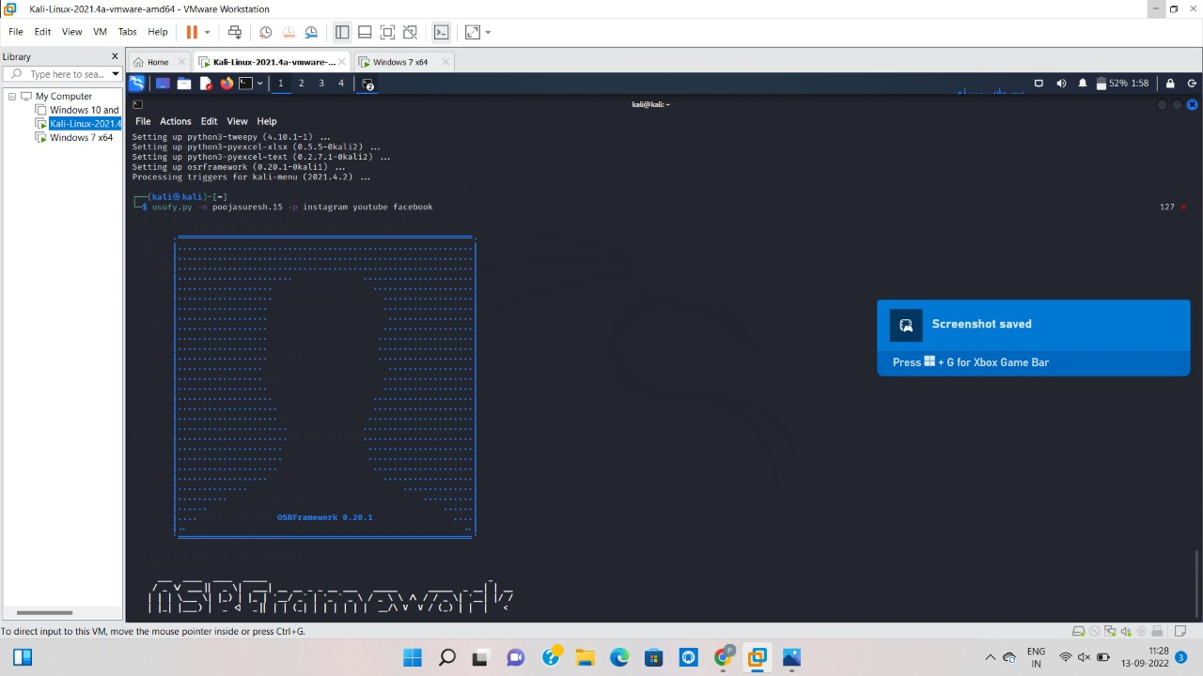

3.USE GOOGLE AND WHOIS FOR RECONNAISANCE

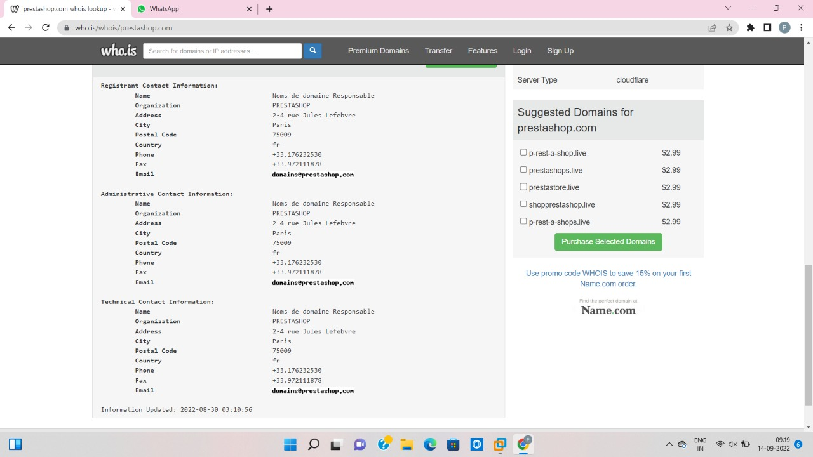

4.USING TRACEROUTE, PING, IFCONFIG, NETSTAT COMMAND

